MYSQL ASSIGNMENT 4
- Create a database named company and a table named employees with the following fields:
- id (INT, Primary Key, Auto Increment)
- name (VARCHAR(100))
- position (VARCHAR(100))
- salary (DECIMAL(10,2))
- date_of_joining (DATE)

- Insert the following data into the employees table:
- John Doe, Manager, 55000.00, 2020-01-15
- Jane Smith, Developer, 48000.00, 2019-07-10
- Alice Johnson, Designer, 45000.00, 2021-03-22
- Bob Brown, Developer, 50000.00, 2018-11-01

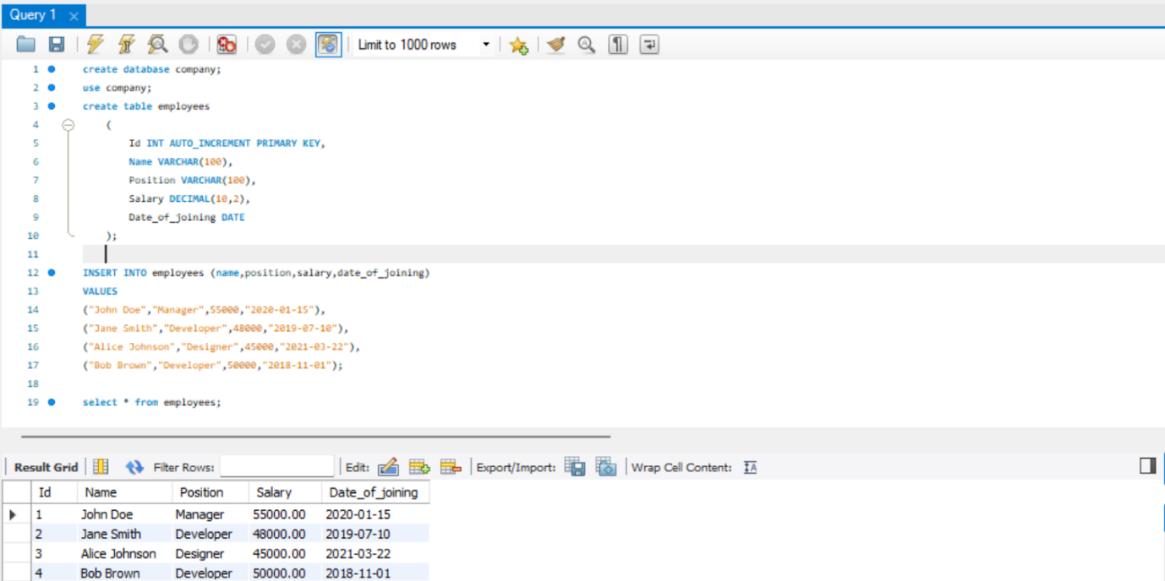

- Write a query to retrieve all employees who are Developers.

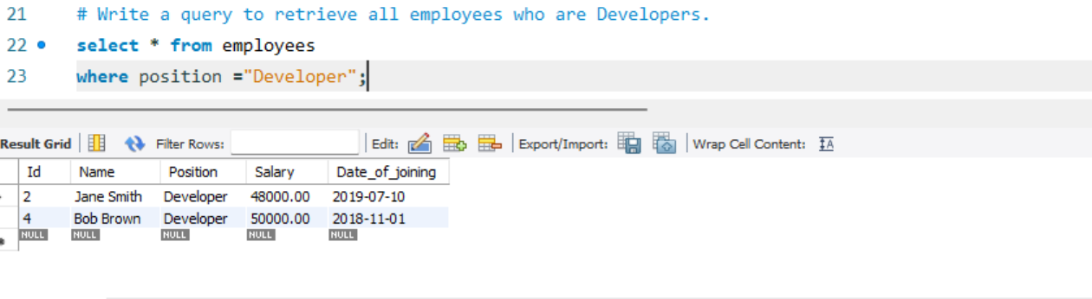

- Write a query to update the salary of Alice Johnson to 46000.00.
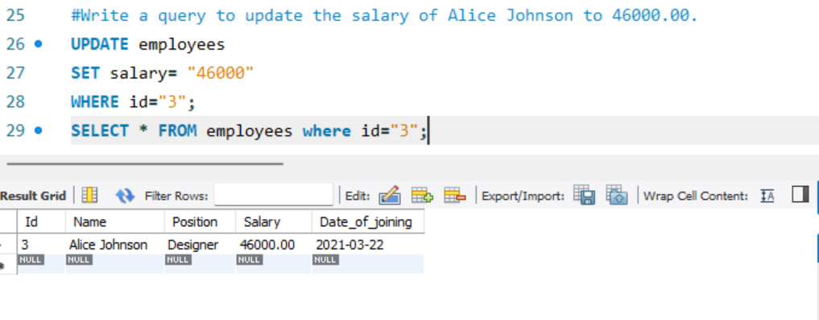

- Q5 Write a query to delete the employee record for Bob Brown.
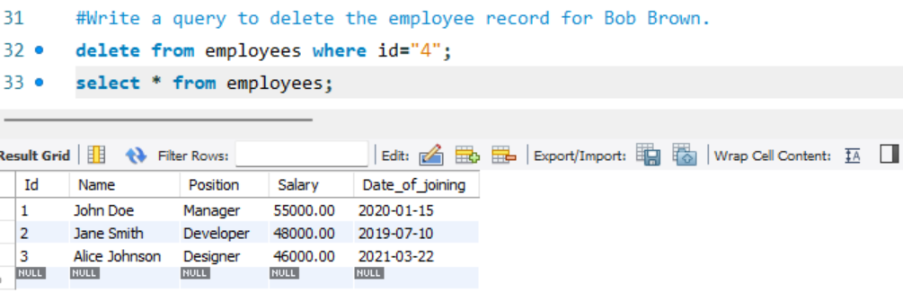
- Write a query to find the employees who have a salary greater than 48000.
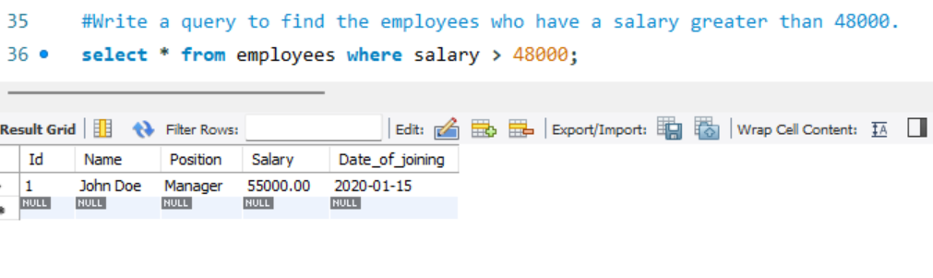
- Write a query to add a new column email to the employees table.
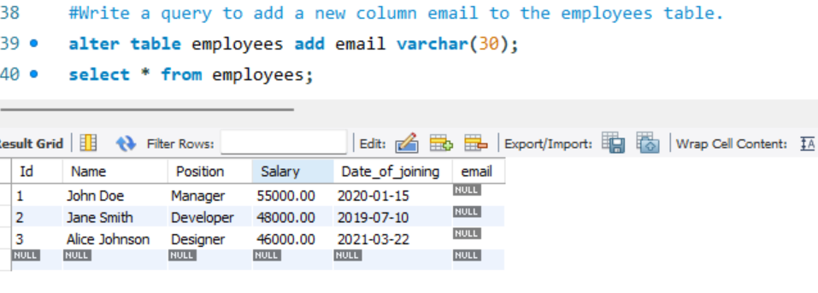
- Write a query to update the email for John Doe to john.doe@company.com.
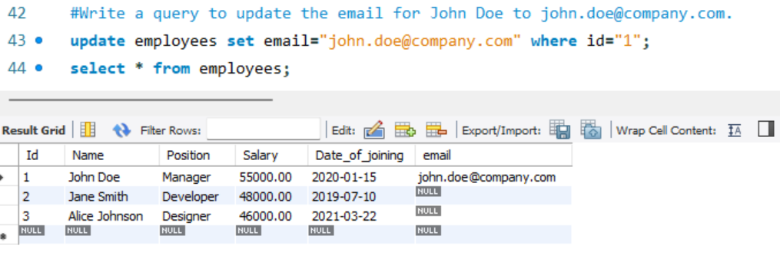
- Write a query to retrieve only the name and salary of all employees.
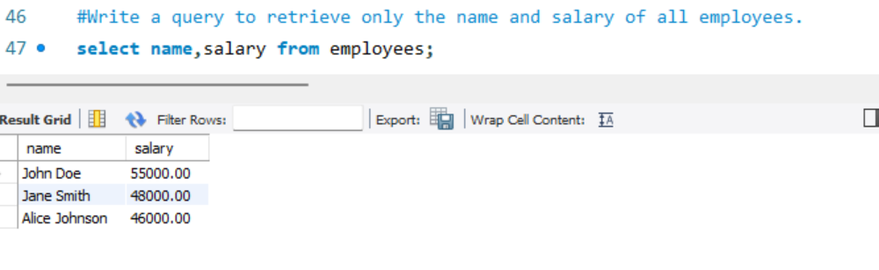
- Write a query to count the number of employees who joined after January 1, 2020.
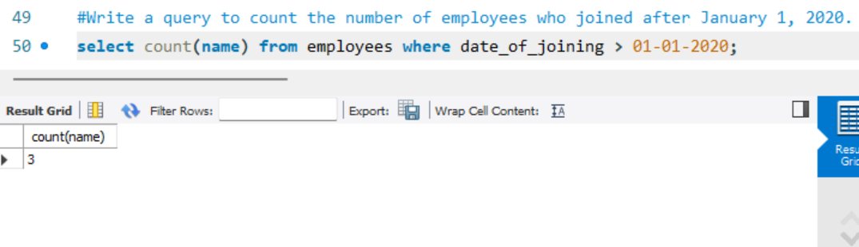
- Write a query to order the employees by salary in descending order.
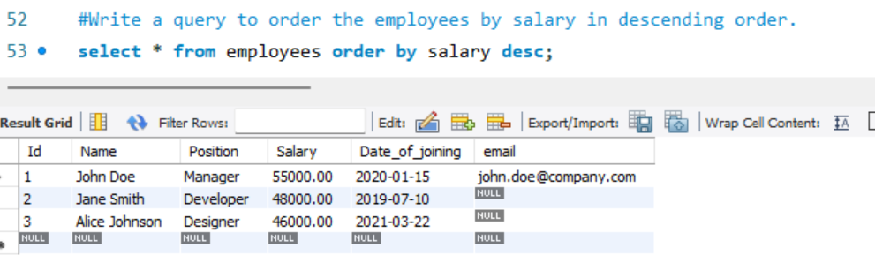
- Write a query to drop the email column from the employees table.
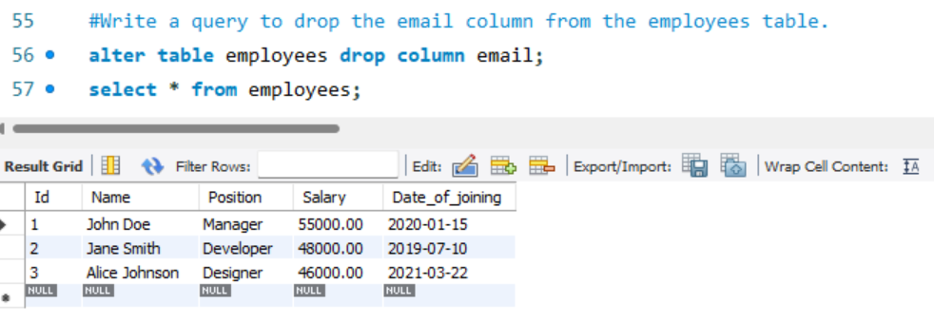
- Write a query to find the employee with the highest salary.
